## DATA MANAGEMENT PROJECT REPORT

(Project Semester: August-December 2020)



**HUMAN RESOURCES TRANING ANALYSIS**

Submitted by

Ravitesh Chaudhary 11809517

Program and Section: B.Tech(CSE), KM078

Course Code: INT217

Under the Guidance of

### Savleen Kaur - 18306

**Discipline of CSE/IT**

**Lovely School of Computer Science & Engineering**

**Lovely Professional University, Phagwara**

**CERTIFICATE**

This is to certify that Ravitesh Caudhary bearing Registration no. 11804915 has completed INT217 project titled, **“HUMAN RESOURCE MANAEMENT”** under my guidance and supervision. To the best of my knowledge, the present work is the result of his original development, effort and study.

### Savleen Kaur

**School of Computer Science & Engineering Lovely Professional University**

**Phagwara, Punjab.**

Date: 15 October 2020

## DECLARATION

I, Ravitesh Chaudhary, student of B.Tech CSE under CSE/IT Discipline at, Lovely Professional University, Punjab, hereby declare that all the information furnished in this project report is based on my own intensive work and is genuine.

Date: 15October 2020

Registration No.: 11804915 Ravitesh Chaudhary

## ACKNOWLEDGEMENT

I would like to express my special thanks of gratitude to my teacher Mrs. Savleen Kaur who gave me the golden opportunity to do this wonderful project of analysis of the data of a superstore namely “HUMAN RESOURCE TRANNING ANALYSIS” which also helped me in doing a lot of research and I came to know about so many new things. I am thankful to them. Secondly, I would also like to thank my parents and friends who helped me a lot in finalizing this project within the limited time frame.

## Table of Content

1. Introduction
2. Scope of the Analysis
3. Analysis on dataset (for each analysis)
   1. Introduction
   2. General Description
   3. Specific Requirements, functions and formulas
   4. Analysis results
   5. Visualization
4. List of Analysis with results
5. References
6. Bibliography

## INTRODUCTION

Data Analysisis a process of inspecting, cleansing, transforming, and modeling data with the goal of discovering useful information, informing conclusions, and supporting decision- making. Data analysis has multiple facets and approaches, encompassing diverse techniques under a variety of names, while being used in different business, science, and social science domains.

Today's work environment requires employees to be skilled in performing complex tasks in an efficient, cost-effective, and safe manner. Training (a performance improvement tool) is needed when employees are not performing up to a certain standard or at an expected level of performance. The difference between actual the actual level of job performance and the expected level of job performance indicates a need for training. The identification of training needs is the first step in a uniform method of instructional design.  
  
A successful training needs analysis will identify those who need training and what kind of training is needed. It is counter-productive to offer training to individuals who do not need it or to offer the wrong kind of training. A Training Needs Analysis helps to put the training resources to good use.

HR TRANNING ANALYSIS contains the following data fields: -

* Employee Id – Unique Employee Id provided by the company
* Participation name – Contains date and time on which the match is held.
* Business Unit – The level as Group A, B, C, D etc.
* Region– Stadium in which match is held.
* Training Name– City in which match is held.
* Training Type – Host team name.
* Trainer Type – No of goals scored by the home team
* Trainer Name – No of goals scored by the away team.
* Start Date – Away team name.
* End Date – no. of people coming to enjoy the particular match.
* No of days– goals scored by the home team by half time.
* Online/Classroom – goals scored by the away team by half time.
* Job Brand – Name of training

## SCOPE OF ANALYSIS

We want to see and analyze the Type of training and trainer type the employees generally follow to learn and work upon the lagging segments and outperforming employees accordingly: -

1. Training type by department
2. Training Analysis Yearly
3. Training Delivery Type
4. Top 10 Trending Trainings
5. Training Type analysis

Aim of this project is to answer the above objectives in the form of visualization by creating a dashboard to convey the answers effectively and efficiently

# ANALYSIS OF DATASET

1. **Training type by department**

**Description:**

There are total 8 departments and in each department an employee takes either skill development or professional development as training type. This analysis is done to obtain the objective of determining the no of employees that have taken the training in a specific department in the given year and in which country.

Slicer

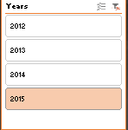

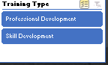

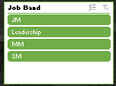

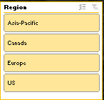

### Specific function and requirements

We must create a pivot table to determine the training type by department

and then visualize it on graph.

We can select job band , Region, Year and Training Type from slicer and can perform the analysis.

### Results:

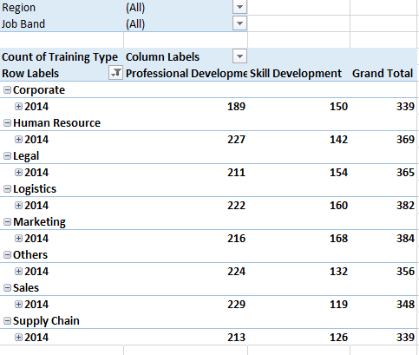

**Visualization:**

The results are then visualized in the form of a stacked bar graph which shows the different training type in department .

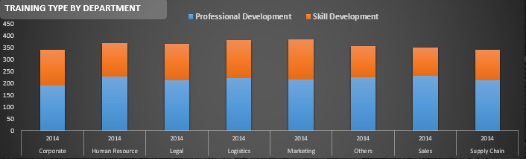

1. Training Analysis Yearly

### Description:

By calculating the no of employees trained in different tanning we can see the trends in the employees that enrolled and completed their training in different years.

### Results:

### 

**Visualization:**

We will use a line graph to visualize the distribution.

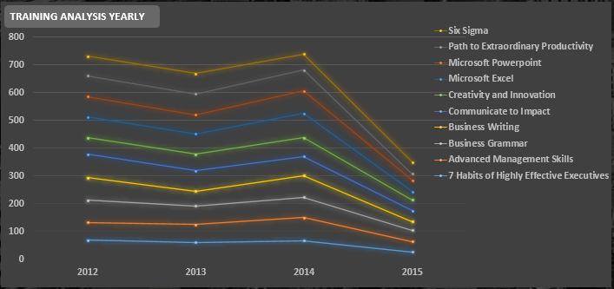

1. **Training Delivery Type**

**Description:**

Describes the delivery type training the employees has taken that is either online mode , external mode or internal mode.

We have to create a pivot table. No specific functions are used.

### Results:

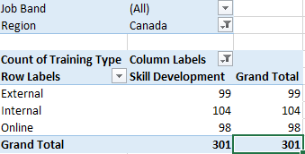

**Visualization:**

The results are visualized with the pie chart and count of each type in specific training type is visualized by calculative fields.

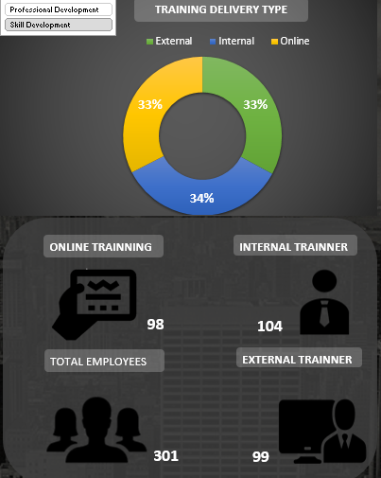

1. Top 10 Trending Trainings:

It shows the top 10 trainings that were taken by the employees in specific year.

### Results:

### 

### Visualization:

We visualize the above results with the help of bar graph.

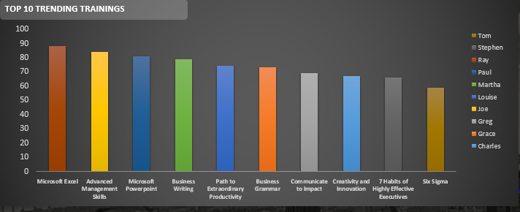

1. Training Type analysis

### Description:

It compares and gives the analysis of which type of training that is either skill type or professional type training is taken by the employee.

.

### Results:

### 

### Visualization :

### 

### We need to use bar graph to visualize this.

### 

### 

**ANALYSIS RESULTS**

1. **Training type by department:**

Now we analyze no of employes trained in particular department with given country and year.



### Training analysis yearly

### we can easily see the trend in no of employees that took training . we can also analyze that there is fall in no of people enrolled in any training in year 2015.



1. **Training Delivery Type:**

We can compare the no of employee trained through different methods. This helps the company to understand whether the employees require on the job training method or apprentice type.

### 



1. **Top 10 Trending Trainings:**

We can see that ms office as most trending type of training in year 2014.



1. **Training Type analysis**

One can analyze that which type of training do employees require and the employees generally lack in.. We can see skill development type training is mostly preferred.

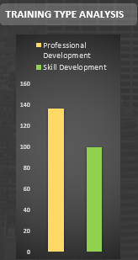

# Final Dashboard

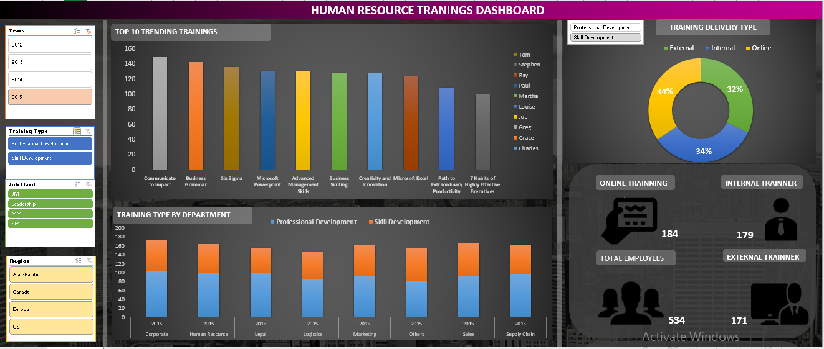 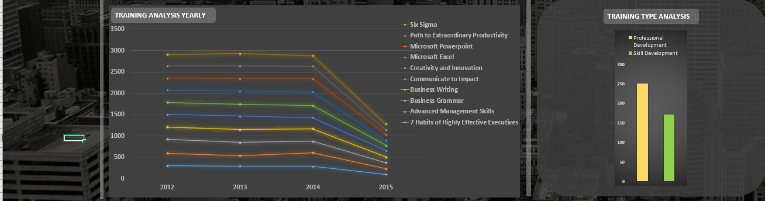

**REFERENCES AND BIBLIOGRAPHY**

* Youtube
* Kaggle
* easyexcell